**Microprocessor and Computer Architecture Laboratory**

**UE19CS256**

**4th Semester, Academic Year 2020-21**

Date:

|  |  |  |
| --- | --- | --- |
| Name: Nihal T M | SRN: PES2UG21CS333 | Section: F |

Week#____6_______ Program Number: ____1__

**Write an ALP to find the length of a given string**

1. ARM Assembly Code (1).

@ ALP to find the length of the given string

.data

str:.asciz "My name is Nihal T M"

len:.word 0

.text

ldr r1,=str

ldr r2,=len

mov r3,#0 @ temporary variable containing the length of the string as we traverse

loop:

ldrb r4,[r1],#1

cmp r4,#0

beq end

add r3,r3,#1

b loop

end:

swi 0x11

.end

1. Output Screen Shot (One Example of your choice)

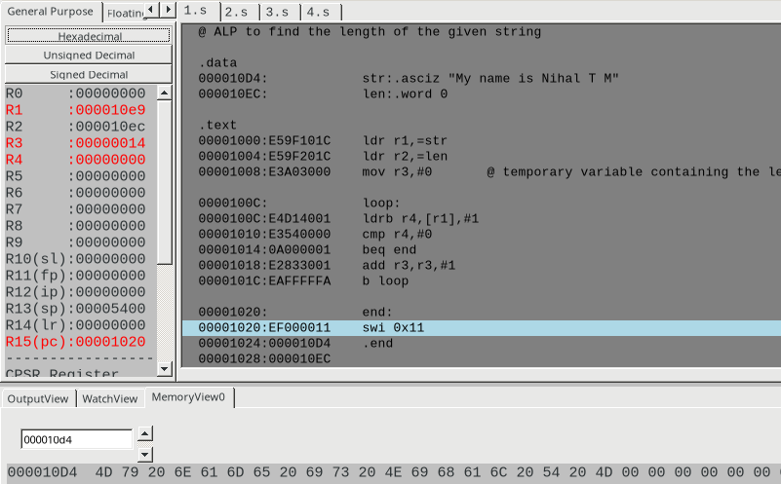

Week#____6______ Program Number: ____2__

**Write an ALP to copy string from one location to another**

1. ARM Assembly Code (1).

@ ALP to copy a string from one memory location to another

.data

str:.asciz "My name is Nihal T M"

copy:.asciz ""

.text

ldr r1,=str

ldr r2,=copy

loop:

ldrb r3,[r1],#1

cmp r3,#0

beq end

strb r3,[r2],#1

b loop

end:

ldr r0,=copy

swi 0x02

swi 0x11

.end

1. Output Screen Shot (One Example of your choice)

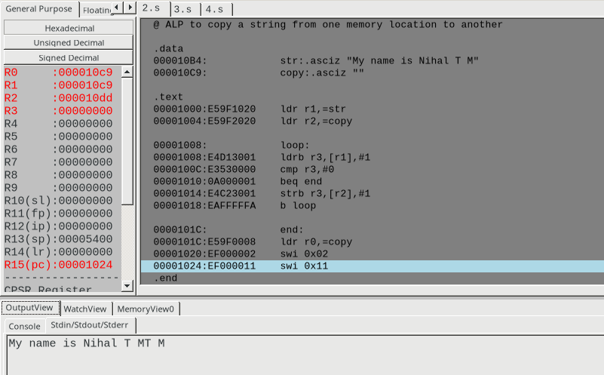

Week#____6_______ Program Number: ____3__

**Write an ALP to find whether a given character is present in a string.**

1. ARM Assembly Code (1).

@ ALP to check if a give character is present in the given string

.data

str:.asciz "My name is Nihal T M"

char:.asciz "N"

not_present:.asciz "The given character is not present in the given string!"

present:.asciz "The given character is present in the given string!"

.text

ldr r1,=str

ldr r2,=char

ldrb r3,[r2]

loop:

ldrb r4,[r1],#1

cmp r4,#0

beq fail

cmp r4,r3

beq success

b loop

success:

ldr r0,=present

swi 0x02

b end

fail:

ldr r0,=not_present

swi 0x02

end:

swi 0x11

.end

1. Output Screen Shot -2 (One Example of your choice)
2. when character is present in the string:

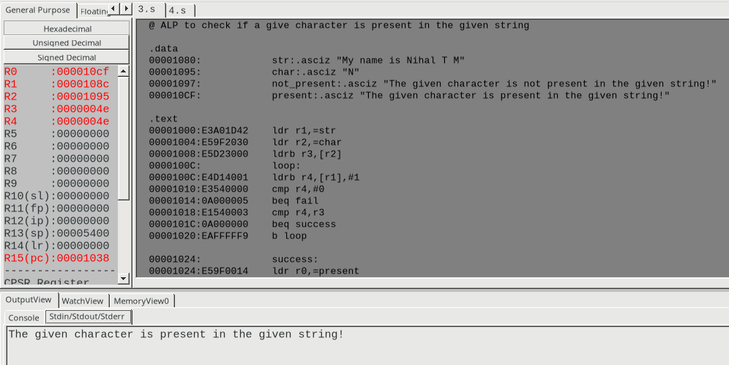

1. when the given character is not present int he given string: (searching for Z)

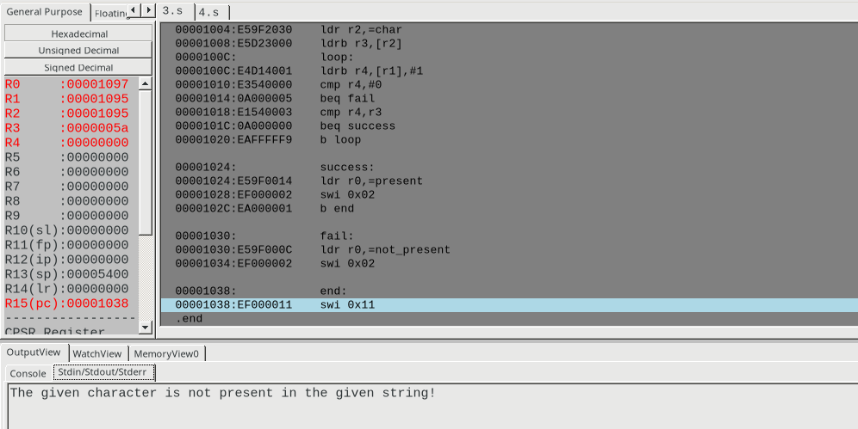

Week#____6_______ Program Number: ____4_

**Write an ALP to find how many times a given character is present in a string**

1. ARM Assembly Code (1).

@ ALP to find the number of occurrences of a give charater in the given string

.data

str:.asciz "My name is Nihal T M"

char:.asciz "a"

.text

ldr r1,=str

ldr r2,=char

ldrb r3,[r2]

mov r4,#0

loop:

ldrb r5,[r1],#1

cmp r5,#0

beq end

cmp r5,r3

addeq r4,r4,#1

b loop

end:

swi 0x11

.end

1. Output Screen Shot (One Example of your choice)
2. The number of occurrences of the character a in given string is stored in the r4 register

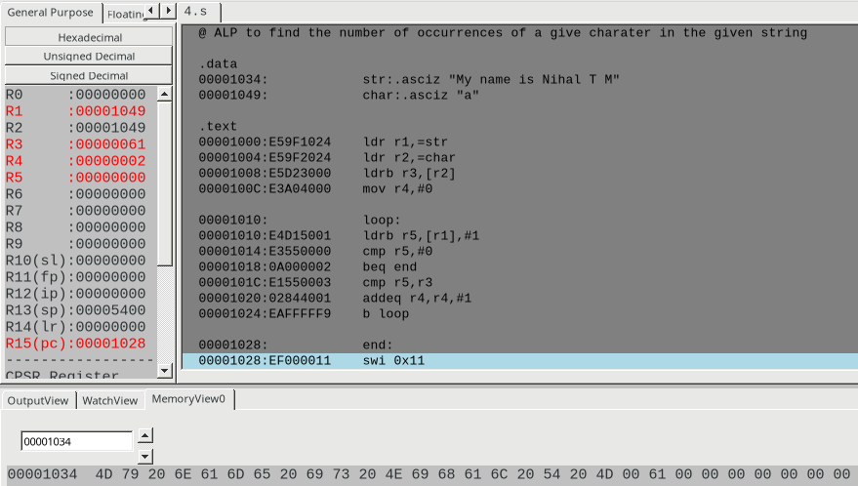

**Disclaimer:**

* The programs and output submitted is duly written, verified and executed by me.
* I have not copied from any of my peers nor from the external resource such as internet.
* If found plagiarized, I will abide with the disciplinary action of the University.

Signature:

Name: Nihal T M

SRN: PES2UG21CS333

Section: F

Date: 24/02/2023